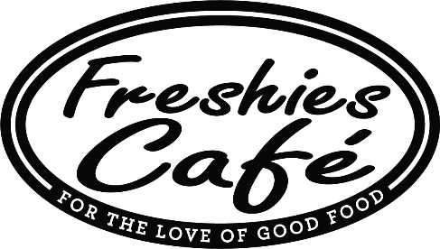
WE GOT SOUPS!
Bowls, cup & Quarts!

December 3, 2020
Corn Chowder
Chicken & Ancient Grains
Split Pea w/Ham

Crispy Chicken Sandwich
House hand battered crispy chicken cutlet, topped with cheddar cheese, bacon, ranch, lettuce, tomato and red onion on a fresh baked roll 9.75

Mozzarella Burger Combo
8oz burger topped with fresh mozzarella, house roasted red peppers, roasted garlic mayo, lettuce, tomato, served with our Jumbo Onion rings 14

Brett’s Roast Beef Panini
Roast Beef, topped with gorgonzola cheese, caramelized onions, horseradish mayo, Arthur Avenue Italian bread panini 9.50

The Berry Barry Chicken Salad Croissant
All white meat chicken salad, topped with a strawberry blueberry reduction, toasted almonds, baby kale, shredded carrots, red onions on a fresh baked croissant 9.50

Kale Caesar Special
Baby Kale served with our house Caesar dressing, avocado, croutons, crumbled goat cheese, chopped tomato, grilled chicken breast 12.75

Thank you everyone!
We have chocolate chip, oatmeal cookies
Double chocolate brownies, apple dumplings
WE GOT SOUPS!
Bowls, cup & Quarts!
December 3, 2020
Corn Chowder
Chicken & Ancient Grains
Split Pea w/Ham

Crispy Chicken Sandwich
House hand battered crispy chicken cutlet, topped with cheddar cheese, bacon, ranch, lettuce, tomato and red onion on a fresh baked roll 9.75

Mozzarella Burger Combo
8oz burger topped with fresh mozzarella, house roasted red peppers, roasted garlic mayo, lettuce, tomato, served with our Jumbo Onion rings 14

Brett’s Roast Beef Panini
Roast Beef, topped with gorgonzola cheese, caramelized onions, horseradish mayo, Arthur Avenue Italian bread panini 9.50

The Berry Barry Chicken Salad Croissant
All white meat chicken salad, topped with a strawberry blueberry reduction, toasted almonds, baby kale, shredded carrots, red onions on a fresh baked croissant 9.50

Kale Caesar Special
Baby Kale served with our house Caesar dressing, avocado, croutons, crumbled goat cheese, chopped tomato, grilled chicken breast 12.75

Thank you everyone!
We have chocolate chip, oatmeal cookies
Double chocolate brownies, apple dumplings

